1. 
2. The way we work with DSL is by specifying the query as JSON object instead of including it in request URI.
3. There are two main groups of queries in the **DSL query structure**.  
   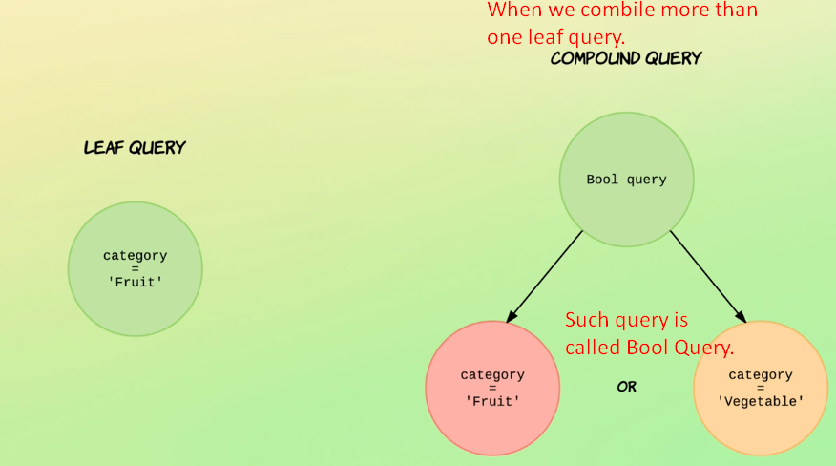
   1. Leaf Query:
   2. Compound Query: Consisting of at least two leaf queries or other compound queries.
4. **Leaf Query**: Looks for value within particular field.
   1. **Example**:
   2. To search for documents with category=fruit.
5. **Compound Query**: Consisting of multiple leaf queries or compound queries. So compound query is recursive in nature.
   1. **Example**:
   2. To search for documents with category=fruit or category=vegetable.  
      So, the above compound query is wrapping two leaf queries with **a bool query** and matches documents with the category of fruit or vegetable.
   3. As you can see we can compound multiple leaf queries or we can nest all the compound query with a **bool query** to create more complex query.
6. 